**The HABS Family Support Team – Autumn 2018 Activities**

The booking/consent form is on the reverse side of this flyer. For further information please contact the HABS Administrator on 01992 303331 Opt 5.



In partnership with

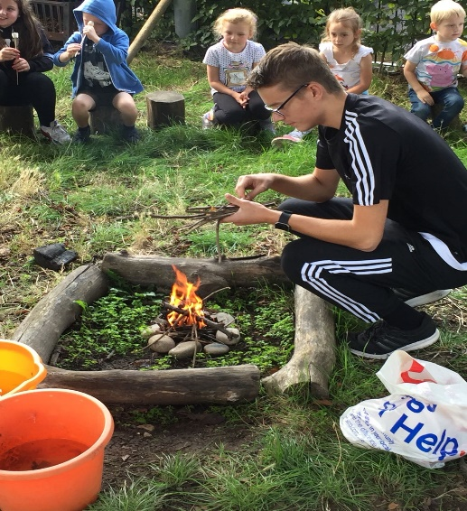

**Wild in the Woods Activities at Wormley School**

Children can come along and work in the forest school area at Wormley School. They will have the opportunity to take part in den building, natural art activities, clay animals, fire building and many more activities.

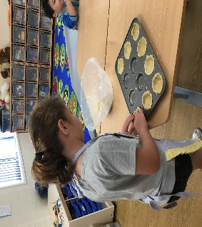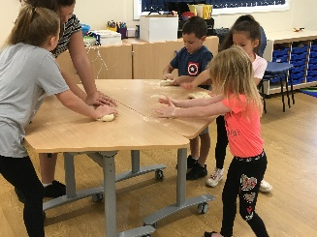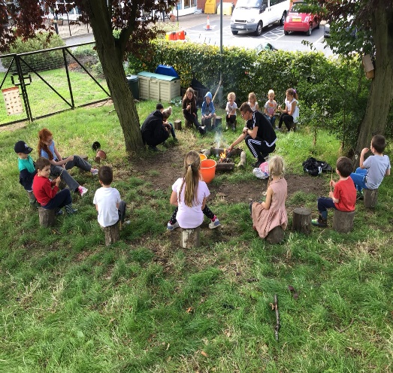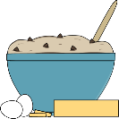

The children will be able to take part in a range of art and craft activities such as:

* Mini Quiches
* Bacon and Cheese bread
* Mini Pizzas
* Chocolate flapjacks
* Jam and Coconut cakes
* Shortbread
* Carrot Cakes
* Lemon biscuits
* Fruit Scones

**Wednesday 31st October**

**Thursday 1st November**

This week will consist of lots of activities such as making:

* Sand Art
* Hama Beads
* Design your own jigsaw puzzle
* Decorate your own porcelain mug
* Painting and drawing.

**Arts and Crafts**

**Cooking**

Monday 29th October

Tuesday 30th October Wednesday 31st October

**Arts and Crafts**

Thursday 1st November

Friday 2nd November

The children will get the opportunity to make a range of sweet and savoury recipes and develop a range of cooking skills.

**Cooking**